**STARAGILE AWS ASSIGNMENT -1**

1. **Sign in to the AWS Management Console:** Go to the AWS Management Console and sign in to your AWS account.

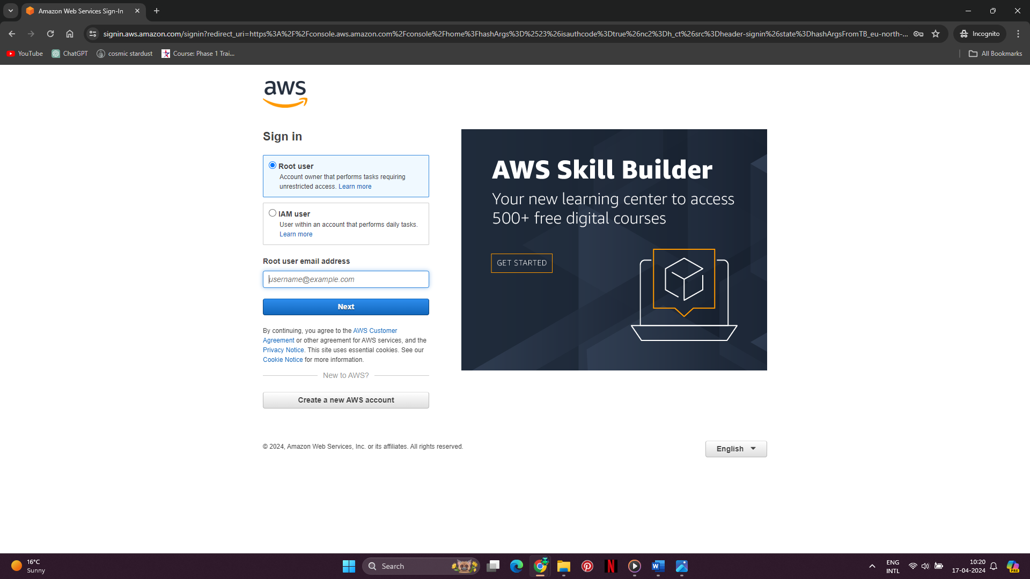

1. **Navigate to EC2:** From the AWS Management Console, navigate to the EC2 service.

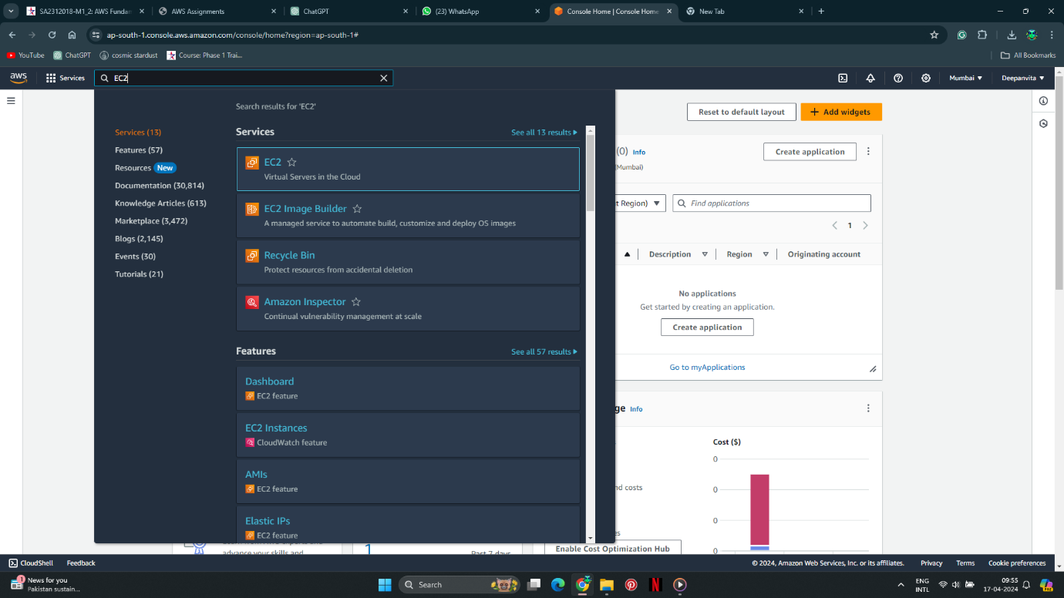

1. **Launch Instance:** Click on the "Launch Instance" button to start the process of launching a new EC2 instance.

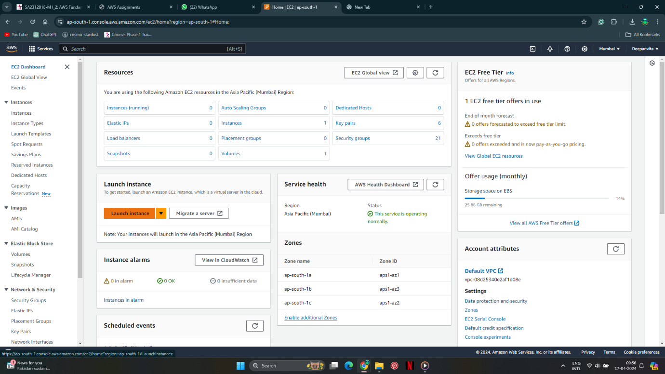

1. **Choose an Amazon Machine Image (AMI):** Select "Ubuntu Server 22.04 LTS" as the AMI for your instance. This fulfills the requirement for Ubuntu 20.04.

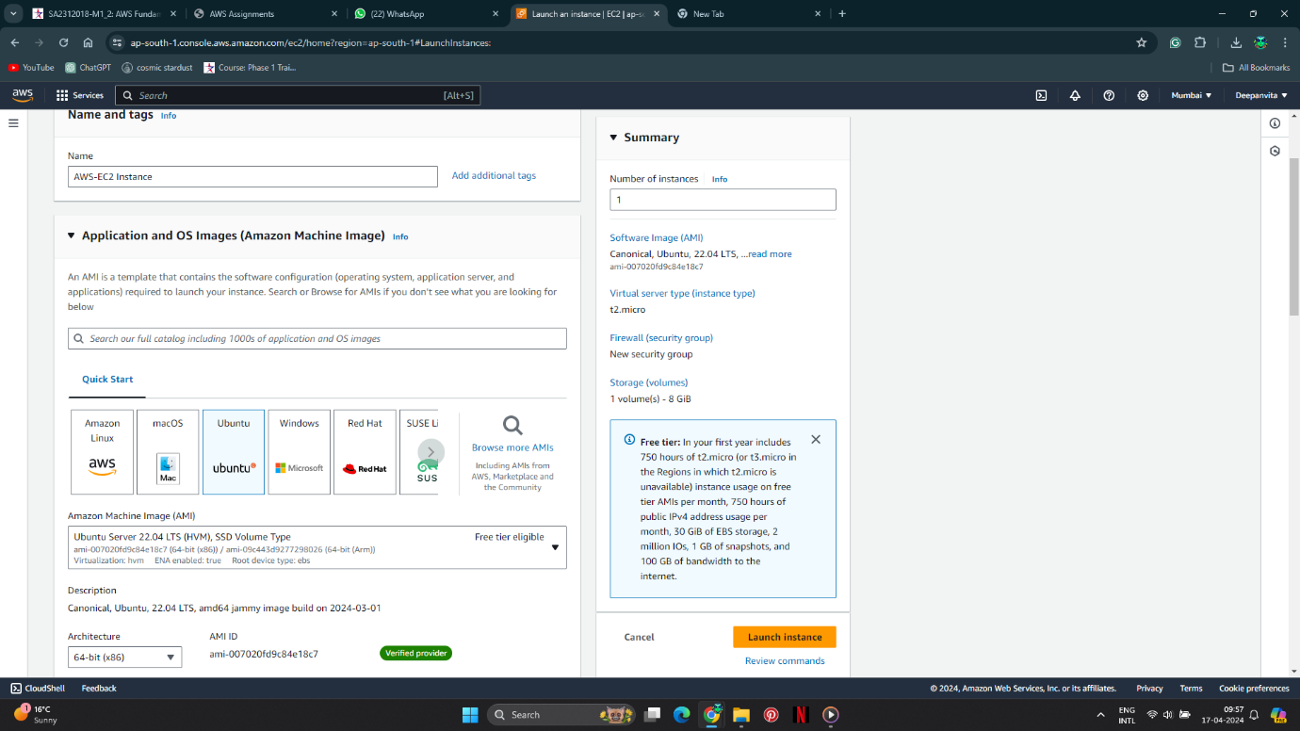

1. **Choose Instance Type:** Select an instance type with 8 GB of RAM. "t2.micro" which comes with 8 GB of RAM. Ensure that it's an instance with General Purpose SSD storage.



1. **Configure Instance:** Proceed with the default configuration. Ensure that the instance is configured to accept incoming traffic SSH (port 22).

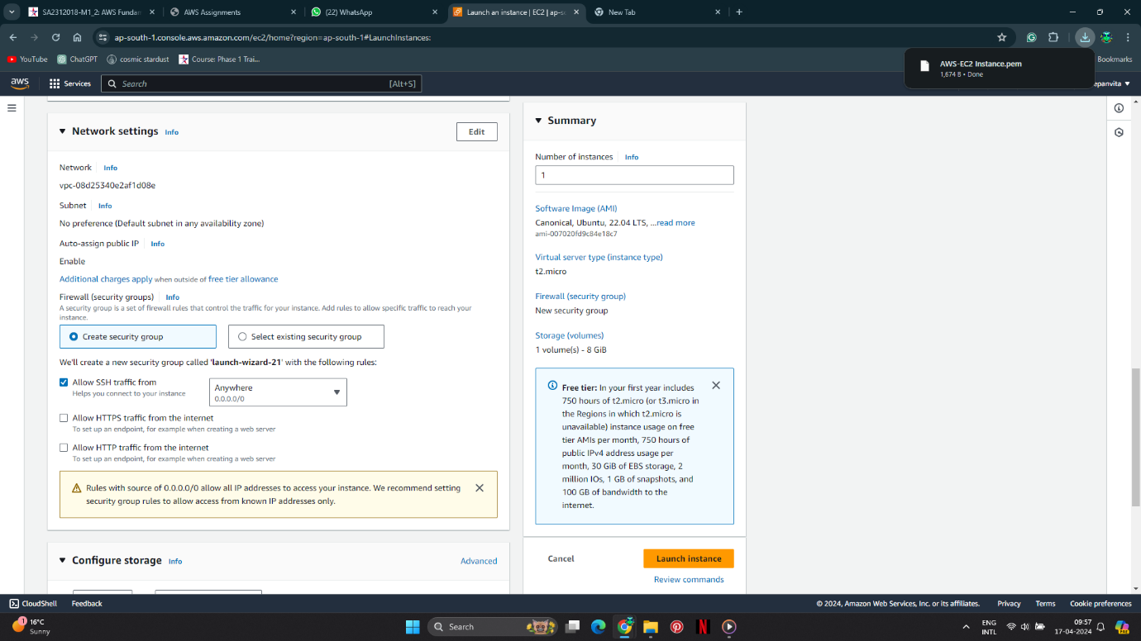

1. **Key Pair:** create or select an existing key pair. This key pair is necessary for SSH access to the instance. Download the private key and store it securely.

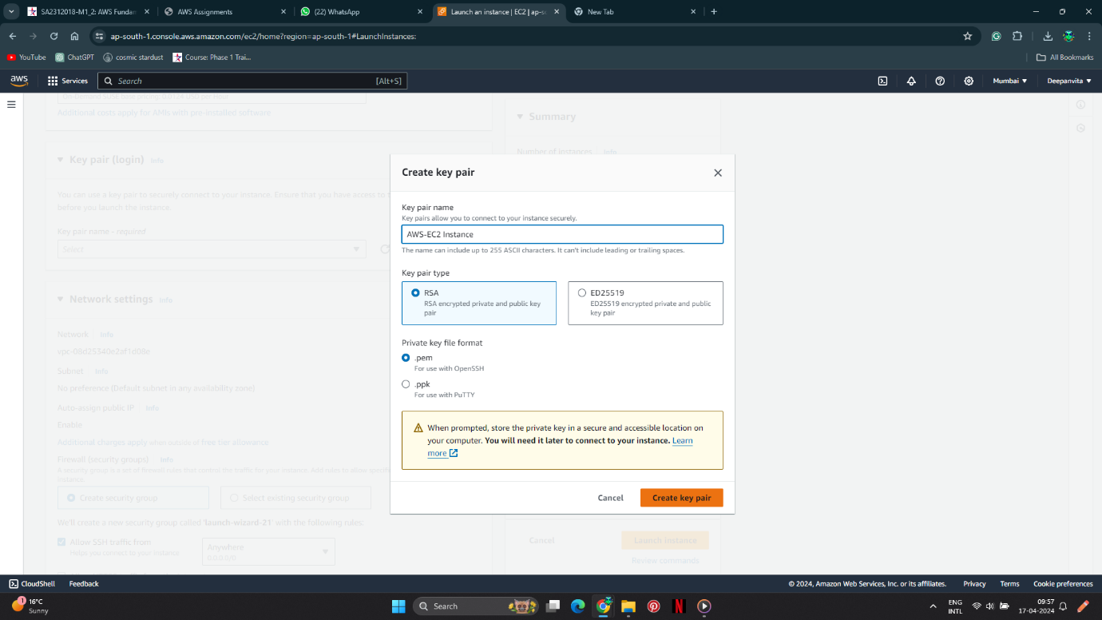

1. **Review Instance Launch:** Review all the configurations.

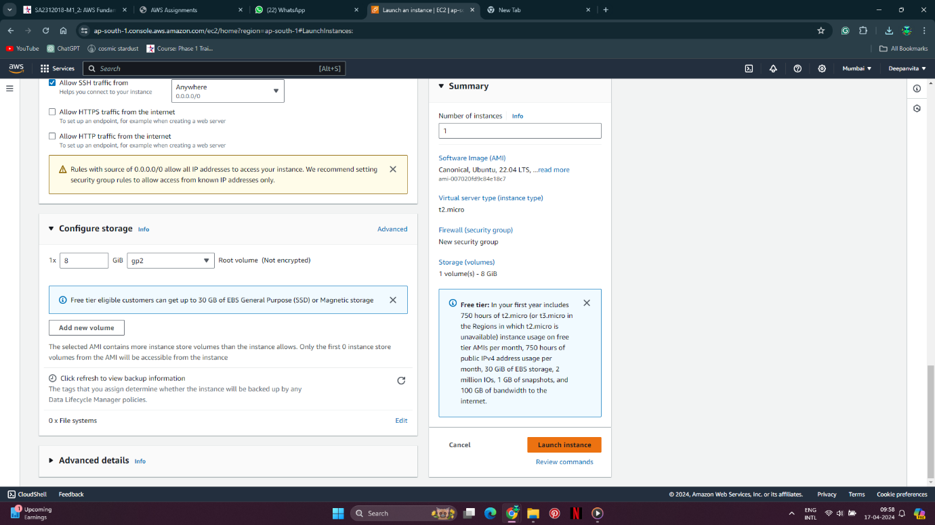

1. **Launch Instance:** Click on the "Launch" button to launch the instance.

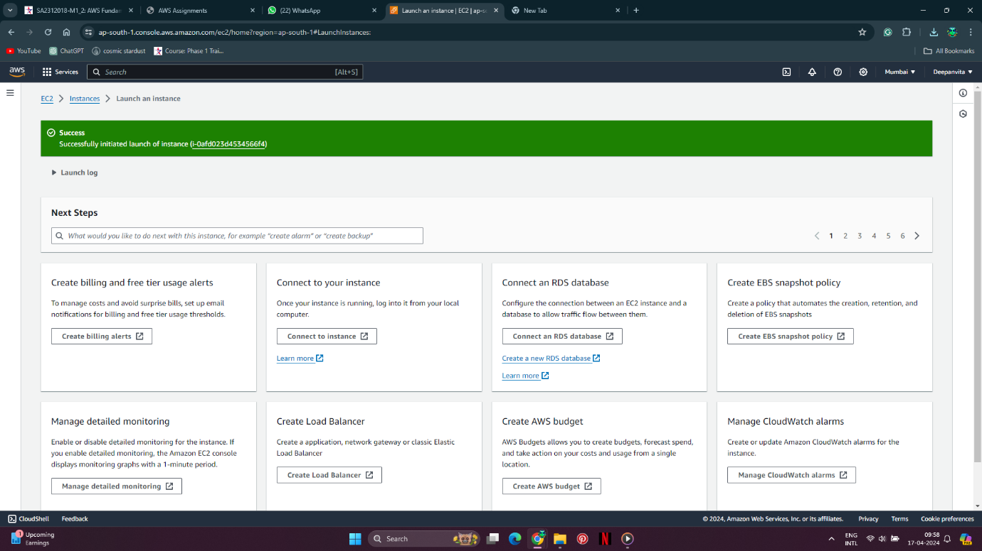

1. **Add Storage:** Add the desired amount of storage. Since the requirement is for General Purpose SSD, you can stick with the default options or customize it based on your needs.
   1. Got to storage section

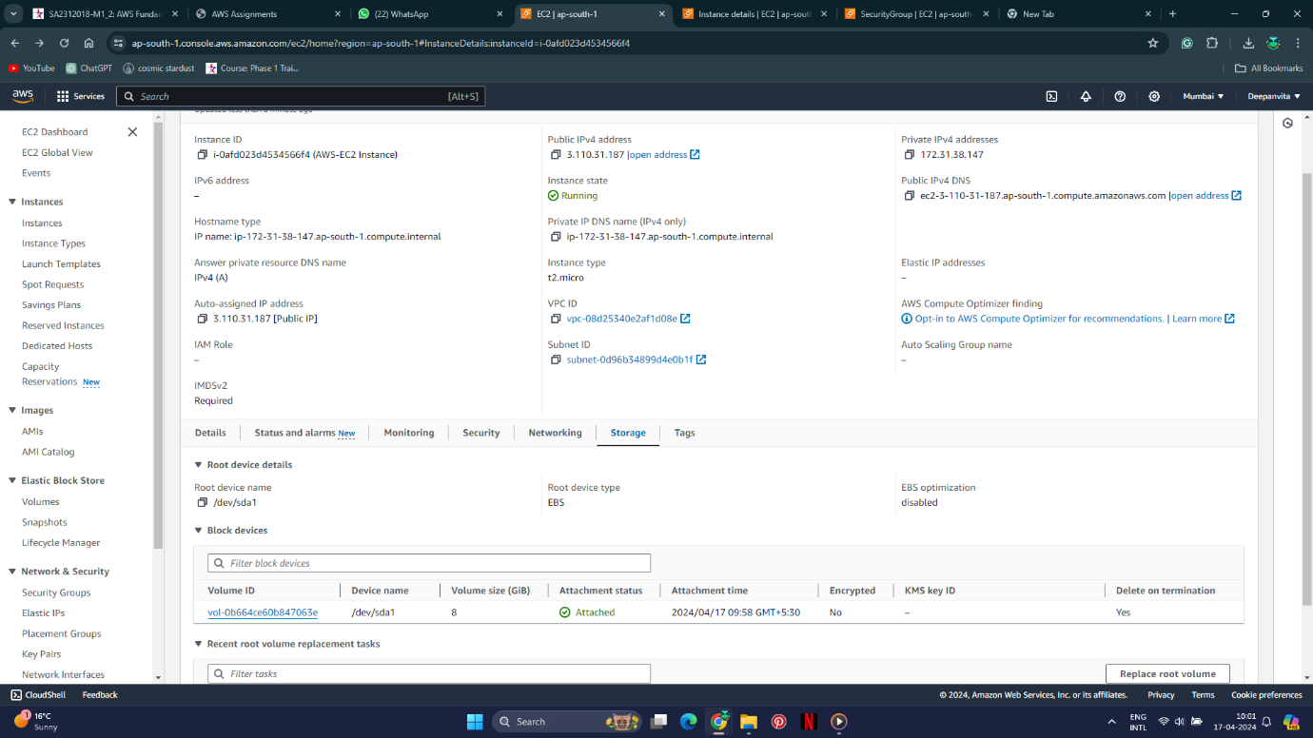

* 1. Create volume

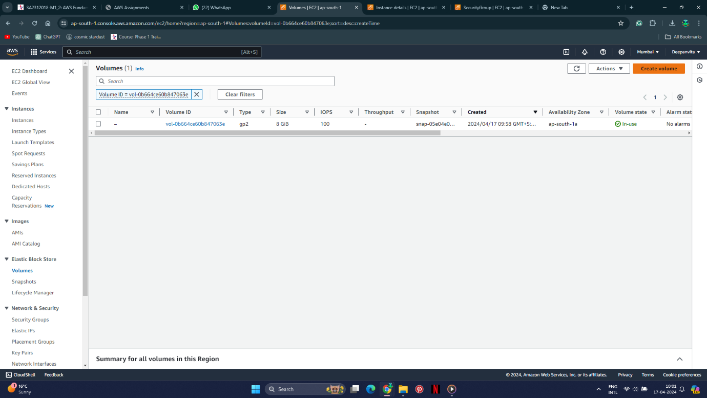

* 1. Choose 8 gb and create volume

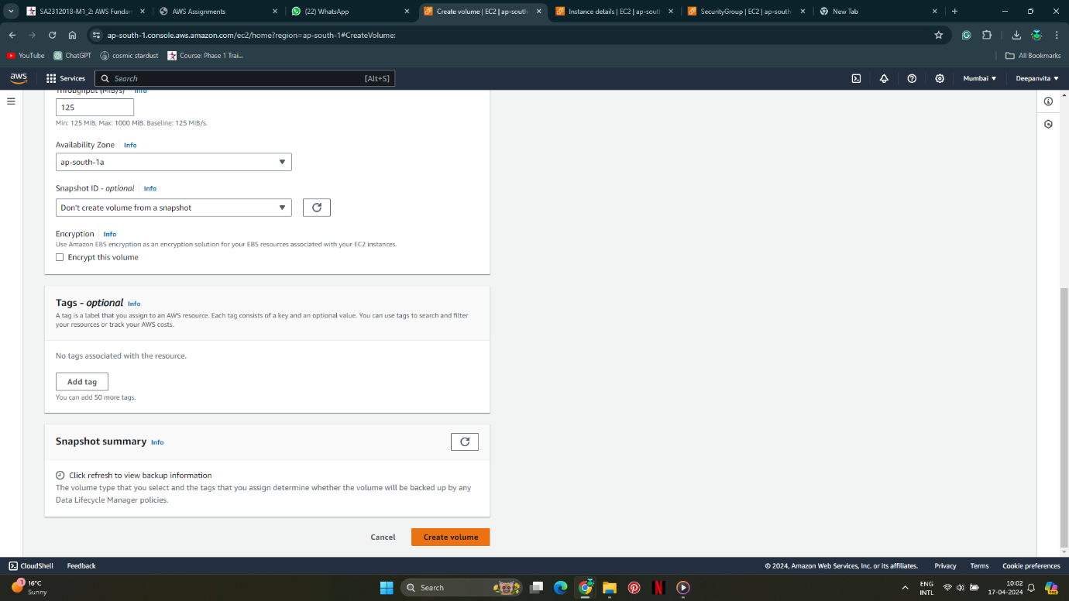

* 1. Done

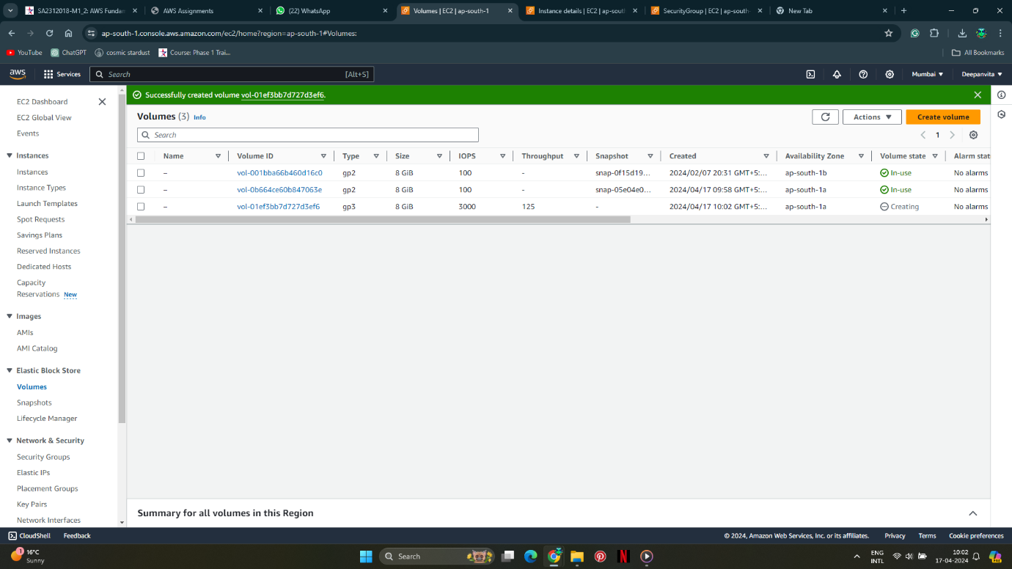

1. **Configure Security Group:** Create or select a security group that allows inbound traffic on port 80 (HTTP) and port 22 (SSH). This ensures that the instance can accept HTTP requests and SSH connections as per the requirements.
   1. Click on security

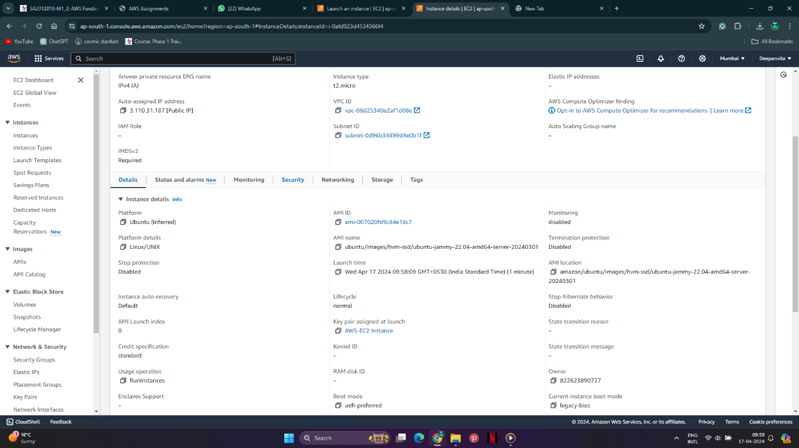

* 1. Select security groups launch wizard

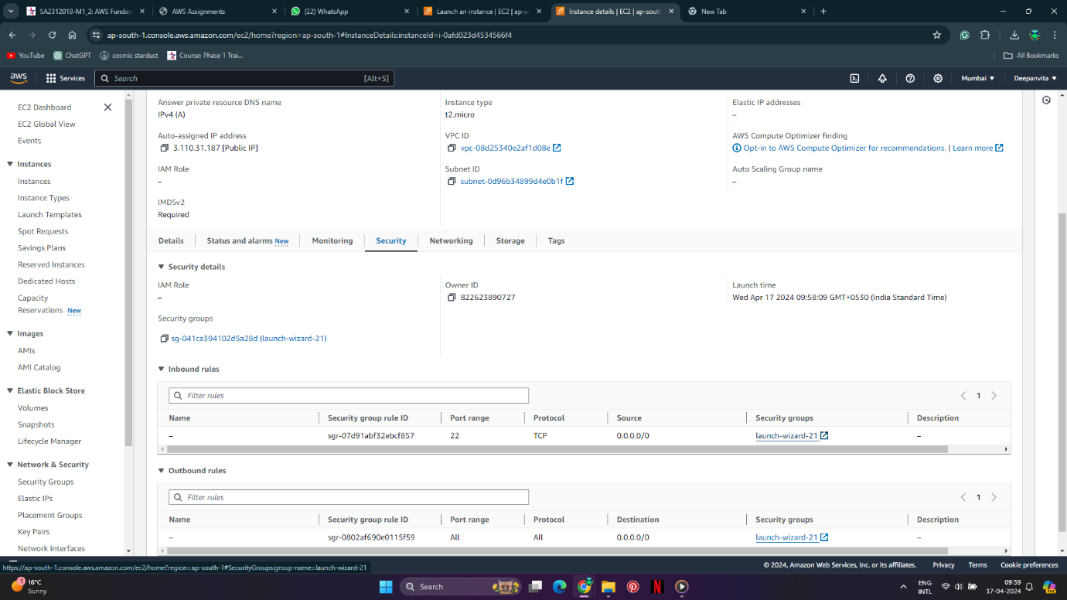

* 1. Click on security group id

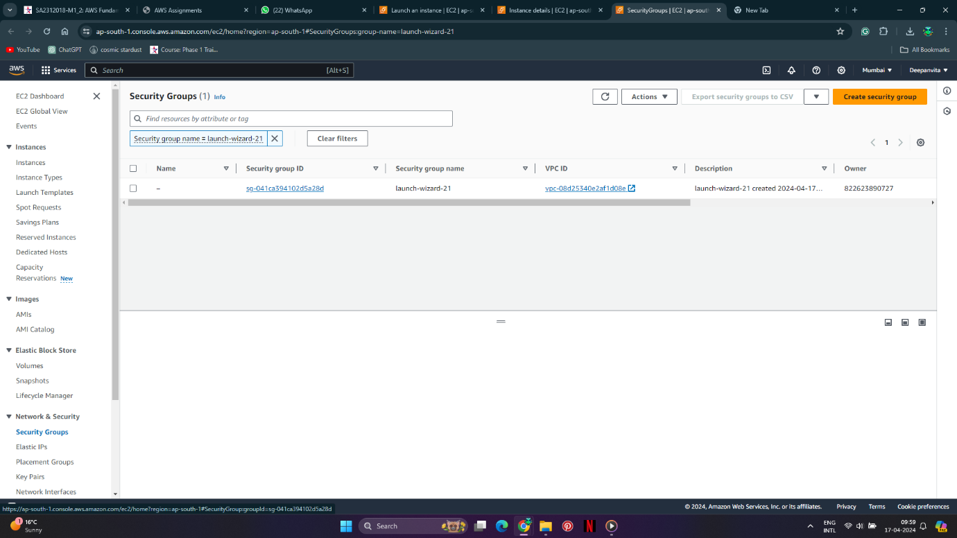

* 1. Edit inbound rules

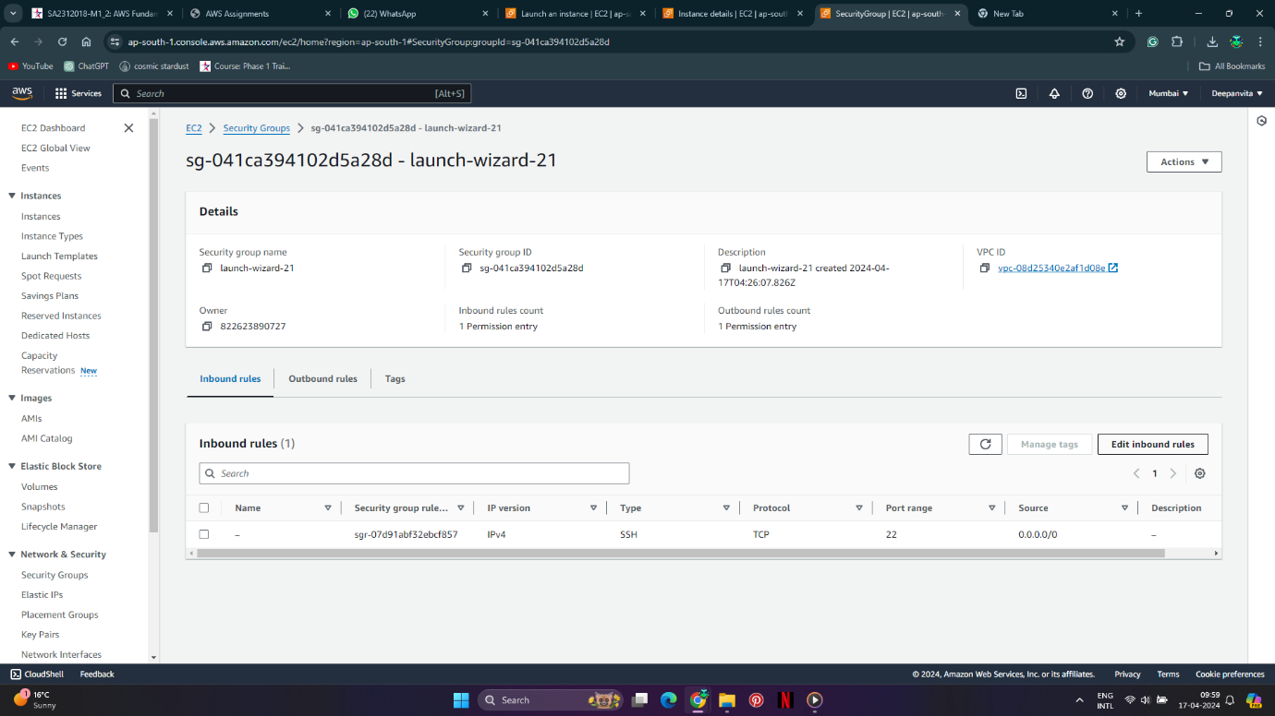

* 1. As SSH is already enabled click on add rule

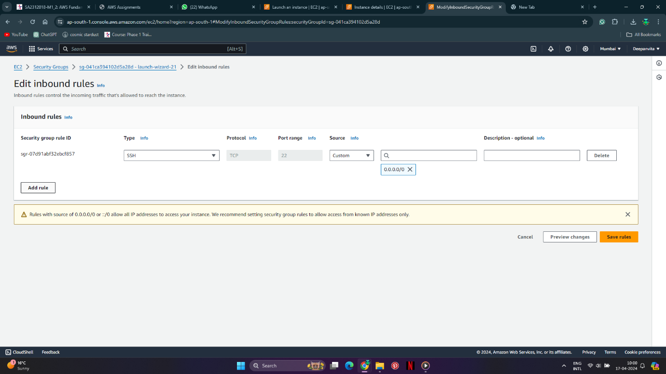

* 1. Choose HTTP

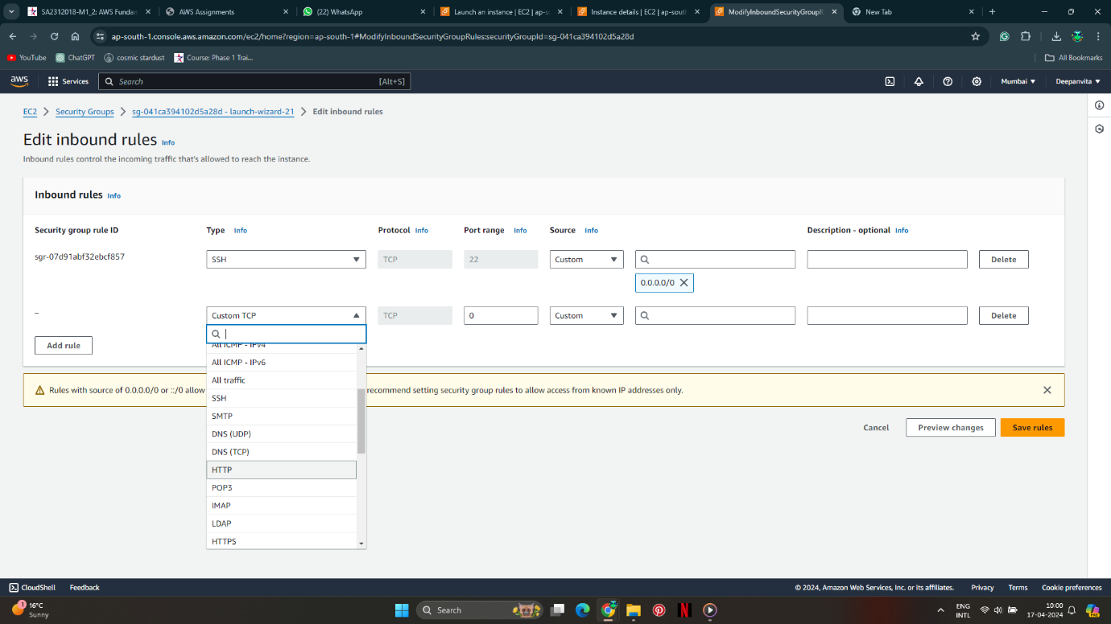

* 1. In source select anywhere-ipv4

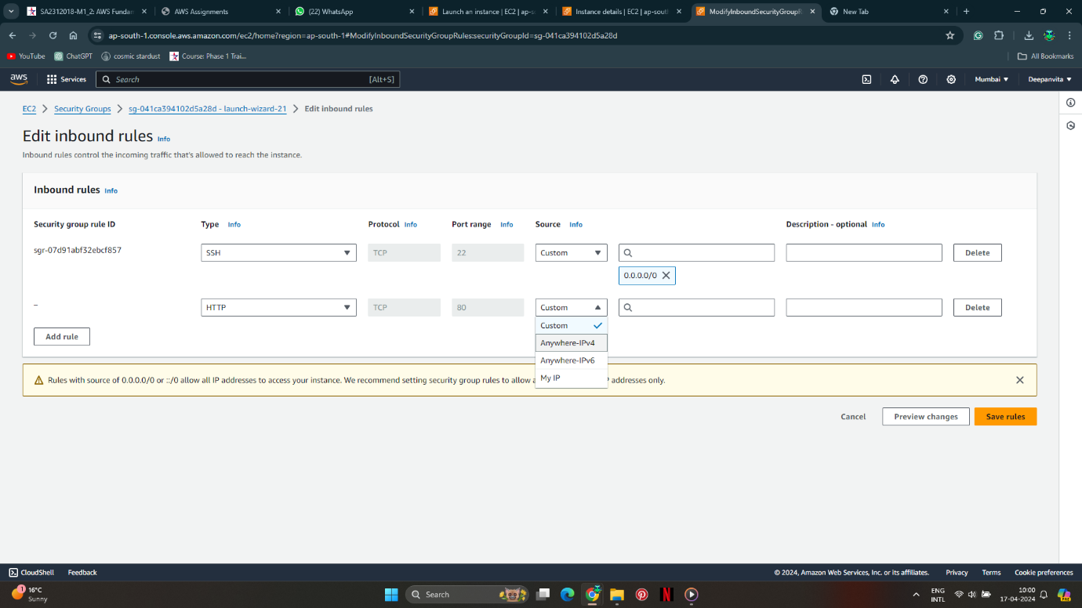

* 1. Save rules and done.

